Shropshire and Wrekin Fire and Rescue Authority
Strategy and Resources Committee
5 February 2015

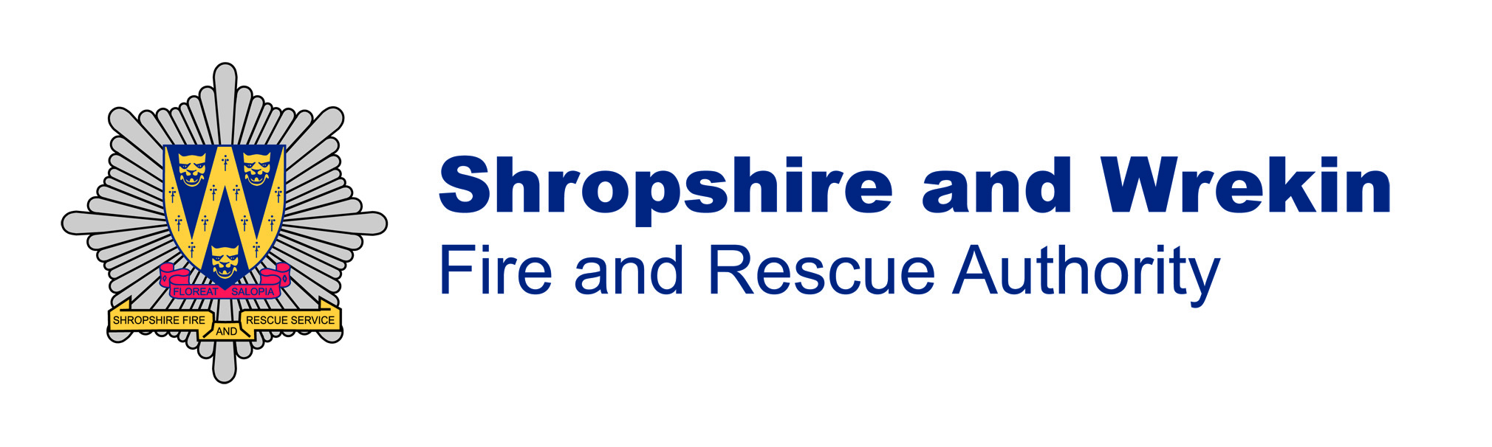
Integrated Risk Management Plan

2015 - 2020

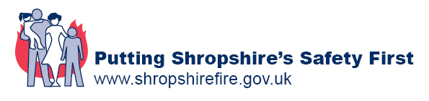

Contents

 | Page
- Foreword by the Chair and the Chief Fire Officer | 3
- Introduction | 4
- What are the Risks? | 5
- How are we doing? | 12
- What more do we plan to do? | 25
- What resources do we need? | 30
- Consultation | 36
Appendix A Action Plan for 2015 to 2020 | 38
Appendix B List of stakeholder organisations | 40
Appendix C Glossary | 41

Foreword

This Integrated Risk Management Plan (IRMP) provides details of what we intend to do over the next 5 years to meet the challenging needs and risks within our community. There are undoubtedly challenges ahead as the numbers of traditional fire-related risks continue to fall but the pressures on the Authority are expanding as more diverse risks and threats increase, such as climatic change and the threat of terrorism, which bring in new levels of complexity.

The IRMP process is a key component of our way of achieving our strategic priorities. It provides an overview of the ongoing risk assessment process we conduct to ensure that we have the correct resources, expertise and knowledge to deliver our aim, which is to “Put Shropshire’s Safety First” and provide the safest most efficient service we can.

Our intention is to ensure that the Service works to a basic principle of directing resources to the greatest need, based upon a risk analysis. Our aim will be to work with partners and collaborators wherever we can meet our strategic aims more easily.

The current economic circumstances, in particular the continuing uncertain outlook for public finances in future, gives real challenges for Shropshire Fire and Rescue Service as we face further reductions in our budget in coming years.

Our staff have worked hard in recent years to implement innovative ways of delivering the Service, whilst at the same reducing the cost to local communities as the budget is reduced. We take every opportunity to consult our local communities on major changes that we are considering and will continue to do so in future. As we move towards the end of the current decade we have set in train a number of reviews of our most risk critical systems and will implement any changes as the reviews are concluded, all within our existing, robust performance management framework.

 | 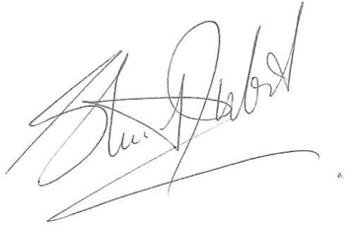  Councillor Stuart West  Chair of the  Fire Authority | 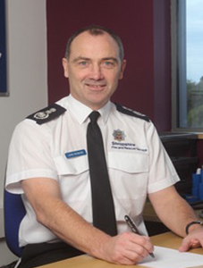 |   John Redmond  Chief Fire Officer

Introduction
Since 2004, all Fire and Rescue Authorities (FRAs) have been required to produce Integrated Risk Management Plans (IRMPs). The Plan is the strategic document that sets out how each FRA will ‘identify and assess all foreseeable fire and rescue related risks that could affect its community, including those of a cross-border, multi-authority and/or national nature. The plan has regard to the Community Risk Registers produced by Local Resilience Forums and other local risk analysis.’ As defined in the terms of the Department for Communities and Local Government National Framework document.

As such the IRMP combines with the Medium Term Corporate Plan and the
Financial Plan to set the strategic direction for Shropshire Fire and Rescue Service. All three Plans will span the same 5 year period and be reviewed and refreshed annually.
The process for achieving this is described below and each stage will form a chapter in the Plan.
Figure1 - IRMP Process flowchart

Risks to property, infrastructure, environment and heritage are important in the work the Service does but the risk to life is given the highest priority. The IRMP shows how the Service will best use its Prevention, Protection and Response resources to combat these risks. The meaning of these terms in a fire and rescue context are as follows:

Prevention – educating people and raising awareness about the risks from fire and other emergencies in an effort to stop incidents occurring

Protection – ensuring buildings have appropriate means of escape and other safety features that improve public and firefighter safety in the event of a fire

Response - dealing with the effects of an incident in its emergency phase

In a Fire and Rescue Service context, risks are made up of the likelihood of a fire or other emergency happening and the severity of its potential effects. In the simplest terms, the things that have an effect on this are people, places, and the way they come together or, more accurately, how the people’s behaviour and the inherent risk in their environment interact. Unfortunately, this makes risk management very difficult. For example the risk posed from a well-informed and aware family, living in an older premises with open fires and aging construction, are very different to those from another person, who doesn’t understand the inherent risks of the property and way their lifestyle might increase the likelihood of a fire happening.

Within Shropshire it is possible to identify some of the higher risk premises, such as hospitals, schools and heritage sites but with all these ever-changing factors it is impossible to measure risk by understanding the lifestyle choices of every person and the condition of every property. Therefore, in order to build a risk profile historical data from incidents is used alongside other valuable information, such as population density, flood risk factors and local and national risk registers, local development plans, census data and computer risk modelling. This provides a picture of what and where the risks to Shropshire are likely to be.

This section outlines the other risks identified across the Service area. The prevention, protection and response resources of the Service are tailored and deployed in ways that attempt to meet these risks in the most effective way.
What are the Risks?

Significant Risks in Shropshire

Hospitals

There are over a dozen public and private hospitals in Shropshire including the Princess Royal Hospital in Telford, The Royal Shrewsbury Hospital and The Redwood Centre in Shrewsbury and the Robert Jones and Agnes Hunt Orthopaedic and District Hospital in Oswestry.

Educational Establishments

Shropshire has over 280 schools and colleges catering for students between the ages of three to eighteen. This figure includes Community Schools, Independent Schools, Academies, Free Schools, Foundation Schools, Voluntary Controlled or Aided Schools, Sixth Forms, Tertiary and Further Education Colleges.

There are also two institutions of higher education in Shropshire: the Telford campus of the University of Wolverhampton and Harper Adams University in Edgmond, near Newport, with a University of Shropshire planned.

Heritage

Historic properties and sites in the County include, Ironbridge Gorge, a UNESCO World Heritage Site. Shropshire is also home to 7,671 listed buildings and sites:

- 131 Grade I - These are classed as properties or sites of exceptional interest, sometimes considered to be internationally important.

- 536 Grade II* - These are classed as properties or sites particularly important with more than a special interest.

- 7004 Grade II - These are classed as properties or sites nationally important and of special interest.

Environment

There are a number of activities carried out within Shropshire, which could result in significant environmental harm in an emergency situation. While it remains the owners’ responsibility to minimise harm in all situations, the Service works with the Environment Agency and other organisations to develop response plans to the most significant risks and to provide resources to minimise the impact from other incidents.

The Service maintains records of environmentally sensitive areas and uses this information to minimise the risk of causing harm through our firefighting or other activities.

Farming

Farming is a very important industry within Shropshire. 81% of Shropshire land area is designated to agricultural production (compared with 68% nationally). There are 3,500 commercial holdings within the Service area, employing 9,500 workers. The industry provides 3.3% of the Gross Value added for Shropshire. The Service maintains good links with the farming community and part of its risk assessment process is to incorporate the specific risks that farming presents. This includes the storage and use of potentially dangerous chemicals in large quantities, predominantly used as fertilisers and the use of highly flammable materials, such as straw and, more recently, the development of biofuels, such as Miscanthus, otherwise known as elephant grass.

Sporting Venues

Shropshire has two main football stadia: Shrewsbury Town’s New Meadow and AFC Telford’s New Bucks Head. Other significant sporting venues include Lilleshall National Sports and Conferencing Centre, Ludlow Racecourse, Hawkstone Park Motocross Circuit and Park Hall stadium in Oswestry.

Site Specific Risks

There are more than 18,000 commercial businesses in the County and some pose risks significant enough for the Service to prepare a risk-based plan within the Site Specific Risk Information process. The planning undertaken for these properties is a requirement placed on the Fire Authority by the Fire and Rescue Services Act 2004 and is known by the relevant section of that Act – 7(ii)(d).

SFRS continually identifies new risk information and updates existing information to support the operational effectiveness of the Service and to ensure the safety of the public and the protection of its firefighters.

SFRS has a database that captures industrial, heritage and societal risks known as the 7(ii)(d) risk information database. This provides invaluable information that is of great help in the swift resolution of emergency incidents and ensuring the safety of firefighters.

Map 3 below shows the risk sites that have currently been identified within Shropshire’s borders. The risk ratings are a function of both the likelihood of an incident occurring and its potential impact.

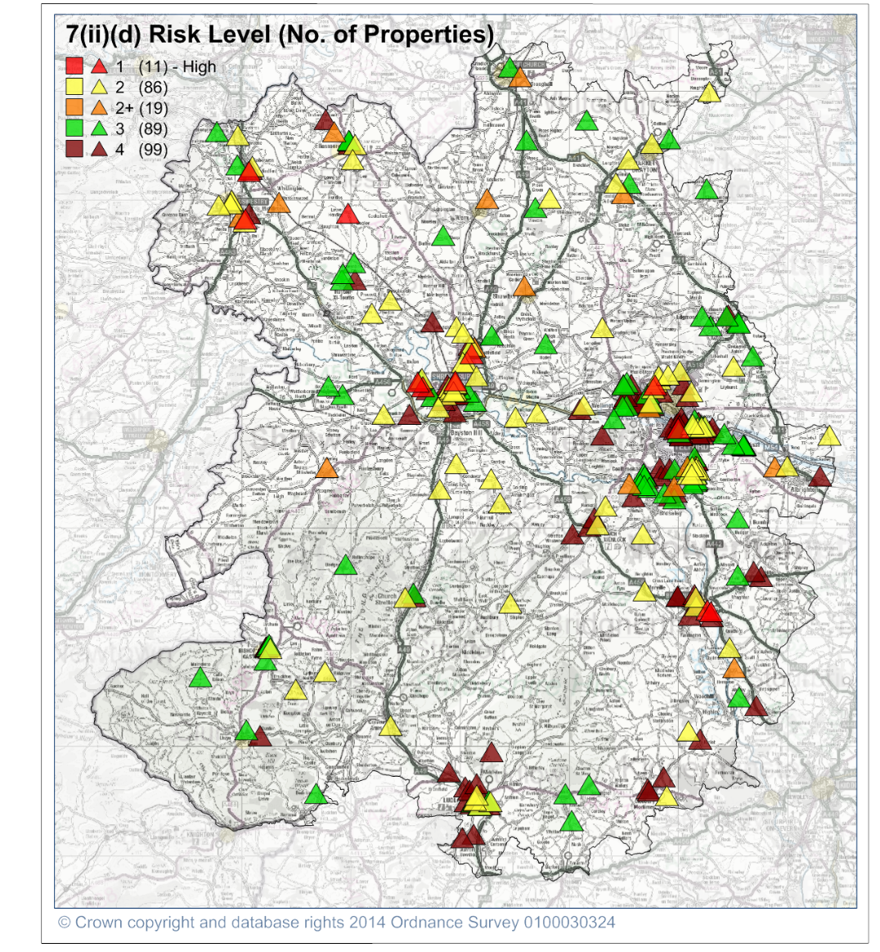

Map 3 – Location and classification of 7(ii)(d) risk sites in Shropshire

Other risks not on specific sites
Transport Infrastructure
Shropshire’s transportation infrastructure relies predominantly on the road and rail networks. A 22km section of the M54 motorway runs from the west side of Telford east to the border with Staffordshire. Other parts of Shropshire have arterial roads, e.g. the A5, A49, A53, A41 and A442, but Shropshire’s size and landscape naturally lends itself to a large network of ‘B’ roads and unclassified lanes.
Statistics taken from Road Casualties Great Britain 2012 indicate that, although rural roads only carry about 42% of road traffic, they account for about 60% of the fatalities that occur in road traffic collisions (RTCs).

The County’s rail links offer a number of mainline routes to locations in England and Wales, including stations that offer further connections, such as Birmingham, Crewe and Wolverhampton. Waterways, such as the River Severn and the 75Km of canals in north Shropshire, carry commercial traffic but they are primarily used for leisure activities.

Flooding Risks

The summer floods of 2007 and the winter floods of 2013/14 demonstrated how susceptible Shropshire is to extreme flooding events. Floods are infrequent but experience has shown that when they are widespread the impact is very high. In both the Gloucester and Somerset floods, it took several years for the community to recover fully. Consequently, through the West Mercia Local Resilience Forum, SFRS and its partner agencies have plans to manage the effects of flooding. This planning has been informed by lessons learned locally, in conjunction with partners in the West Mercia Local Resilience Forum (see next section), in response to the ‘Pitt Report’ following the flooding of 2007, and more recent deployments to national flooding events, where the Service provided mutual aid to other areas across the country.

Map 4 below shows that Shropshire’s susceptibility to flooding.

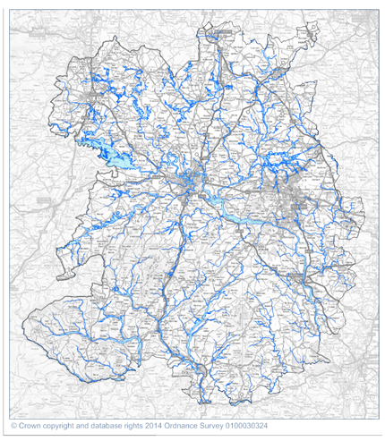
Map 4 – Flood zones in Shropshire

Population Density

There is a strong correlation between the incidence of fire and the level of population in a given area and so the Service has classified every part of the County into various levels of risk:

- High Risk - areas that have more than 10,000 population
- Medium Risk - areas with less than 10,000 population, but more than approximately 1,000
- Low Risk - areas with a pre-defined level of population density with less than 1,000 population

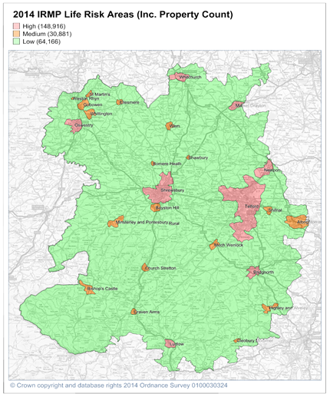
Map 5 shows the current IRMP life risk areas in Shropshire. The total property count, including all residential and commercial properties for each classification, is also displayed.

Map 5 – Current IRMP Life Risk areas within Shropshire

Risk Modelling
SFRS uses the Fire Service Emergency Cover (FSEC) software, as well as other risk analysis tools, to assist in its planning process.

A methodology has been developed for assessing the risk to which the County is exposed and to predict the potential impact on life and property, arising from incidents the Service attends. The Service has a statutory obligation to consider its response to local, regional and national incidents, including new and emerging threats like terrorism.

Standards of Response

There are no national standards for the Fire and Rescue Service. Each Fire Authority must set its own standards, based on the risks it faces and its resources. Using the FSEC software, based on the risk to life, SFRS has developed “response standards”. These identify the geographical areas of greatest risk to life in the County and set targets for fire appliances to attend these areas. Also stipulated within these targets is the number of firefighters to arrive at life risk incidents in these defined areas. These are designed to provide the right balance between delivering a swift and timely public service and maintaining firefighter safety. Together these are known as the Service’s Response Standards.

Having identified the risk levels in each area, the Fire Authority set the following Response Standards for all Life Risk Fires, i.e. fires in those properties where there is potential for people to sleep (and therefore be at a very high risk in the event of a fire) that occur in the County (Table 3).

 | Life Risk Fires Response Standard
Risk Areas | Time to get a minimum of 5 Firefighters to an incident | Time to get a minimum of 8 Firefighters to an incident
High | 10 minutes | 13 minutes
Medium | 15 minutes | 18 minutes
Low | 20 minutes | 20 minutes
Overall Target | 75% | 95%

Table 3 – Life Risk Fires Response Standards

The Life Risk Response Standard is used to guide the Service in how resources are deployed across the County, i.e. the location of fire stations and other resources to achieve the appropriate attendance to a building that is involved in fire within a defined timescale. The standard is primarily about saving saveable life and allows resources to be moved dynamically as incidents take place. For example, if an incident occurs in Shrewsbury, the Mobilising Officer will consider whether fire engines need to be moved into the area to give additional cover, so that the Life Risk Response Standard would be met, if a second incident were to occur.

The Service also measures itself against a second standard, which is designed to give the public a clearer view of what level of service they are receiving from their Fire and Rescue Service (as part of its Public Value process). This is a known as the Public Value Response Standard and relates to every emergency incident the Service attends, no matter what the emergency or where it is. This overarching standard is shown in Table 4, below.

 | Public Value Response Standard
For all emergency incidents | The first fire engine will arrive with a minimum of 4 firefighters within 15 minutes
Target | 87%

Table 4 – Public Value Response Standard

The Fire Authority has also put in place a ‘Resilience Standard’, which states that, even during very busy periods, at least one fire appliance will respond to any call across the County within 20 minutes.

Managing serious incidents

Local Resilience Forum and the Local Community Risk Register

SFRS plays a significant role in the West Mercia Local Resilience Forum (LRF). The LRF is a multi-agency partnership formed to meet the requirements of the Civil Contingencies Act 2004 (CCA 2004). The LRF plans and prepares for local incidents, catastrophic emergencies and malicious threats, including terrorism. LRF Emergency Responders (known as Category 1 Responders) compile a Community Risk Register, which identifies the wide range of potential risks and emergencies it could face. The Risk Register is then used by the Forum to inform its priorities for planning, training and exercising.

National Resilience and the National Risk Register

The Fire Service National Resilience Programme is one part of the Department of Communities and Local Government (CLG) contribution to the Government’s Civil Contingencies Capabilities Programme.

The strategic aim of the programme is to improve the preparedness and resilience of Fire and Rescue Services in England and Wales by maintaining and improving the capability of the national assets, owned by the Government, but operated by each fire and rescue service. These “National assets” (see section XX below) are items of equipment for use in specific circumstances of national catastrophe, such as widespread flooding (major pumping units) or chemical attack (decontamination units). The programme consists of a number of distinct capabilities, which are:

- Chemical, Biological, Radiological, Nuclear and Explosives - CBRN(e)
- Urban Search and Rescue
- Water and High Volume Pumping
- Enhanced Logistical Control

The Government’s National Risk Register of Civil Emergencies (NRR) is a reference document for individuals and organisations that want to be better prepared for emergencies. It provides updated information on the types of civil emergencies that people in the United Kingdom could face over the next five years. It is reviewed by various Government departments and is the basis upon which the LRF considers its local risks.

Shropshire Fire and Rescue Service’s key strategies are based on Prevention, Protection and Response.
How are we doing?

Prevention and protection activities have been successful in reducing the number of emergency incidents the Service has responded to (Figure 2). This proactive approach to risk reduction, which seeks to educate the public and businesses, has also allowed the Service to successfully reduce resources in line with the anticipated risk.

Figure 2 – Total number of Incidents 2004/05 – 2013/14

Prevention

Fire Safety in the Home

SFRS resources have been focused on providing a service to those most at risk. Statistics clearly show that the elderly are at greater risk of injury or death caused by fire.

Case histories prove that fire safety education, aimed at children and young people, has been instrumental in saving their lives and those of their families

During 2012 and 2013 the Service carried out 5,325 successful Home Fire Safety Visits and fitted 3,749 detectors. The Service’s prevention work has led to a downward trend in accidental dwelling fires, especially over the last five years (Figure 3).

Figure 3 – Accidental Dwelling Fires 2004/05 – 2013/14

Specific areas of work also include reassurance following a serious fire or fatality in a local area by means of ‘Quick Strike’ campaigns where we visit people living in the area surrounding an incident and advise them on fire safety while the incident is still fresh in their minds.,

SFRS visits 138 Key Stage Two (KS2) schools and partners with other agencies in delivering a multi-agency education initiative called Crucial Crew to over 3,500 children. SFRS also provides an education programme for under 16 year-olds, who have shown fire-setting behaviour, called I-learn, and works with the Youth Offending Service to deliver a structured education plan.

Deliberate Fire-setting

As well as working to reduce the risk from accidental fires in the home, the Service also works to prevent arson in homes and businesses. We also strive to reduce the significant risk posed by road traffic accidents on Shropshire’s roads.

Arson has a devastating effect on individuals, businesses and communities. SFRS has delivered initiatives to reduce the number of deliberate fires. The Service has worked to ensure that those threatened, or intimidated, receive protection from potential arson attacks via partnership working. The Service targets the risk of arson throughout Shropshire with proactive and reactive interventions. The result has been a reduction in the number of deliberate fires affecting both homes and business premises. (Figures 4 and 5).

Figure 4 – Deliberate Dwelling Fires 2004/05 – 2013/14

Figure 5 – Deliberate Business Fires 2004/05 – 2013/14

Smaller fires, perhaps only involving rubbish, bins or grass (known as secondary fires), do not have the same impact as fires involving people’s property. There is still a risk of injury to people, who set the fires, and others nearby and they are often symptomatic of a wider incidence of anti-social behaviour. Signs of previous fire damage can also badly affect the way an area looks to residents and visitors – another reason why the Service and its partners are working to reduce the level of arson. This work has led to a steady reduction in arson and anti-social behaviour related fires, as illustrated below (Figure 6).

Figure 6 – Deliberate Secondary Fires 2007/08 – 2013/14

Safety on the Road

Working with the lead agencies for road accident prevention, the Police and the local authorities, the Service will continue to take an active part in local and national initiatives to reduce the numbers of people killed and injured on our roads.

SFRS has worked with the West Mercia Safer Roads Partnership to promote and publicise road traffic collision (RTC) reduction strategies, aimed at reducing the number of people killed or seriously injured on Shropshire’s roads.

Figure 7 – RTCs attended 2009/10 – 2013/14

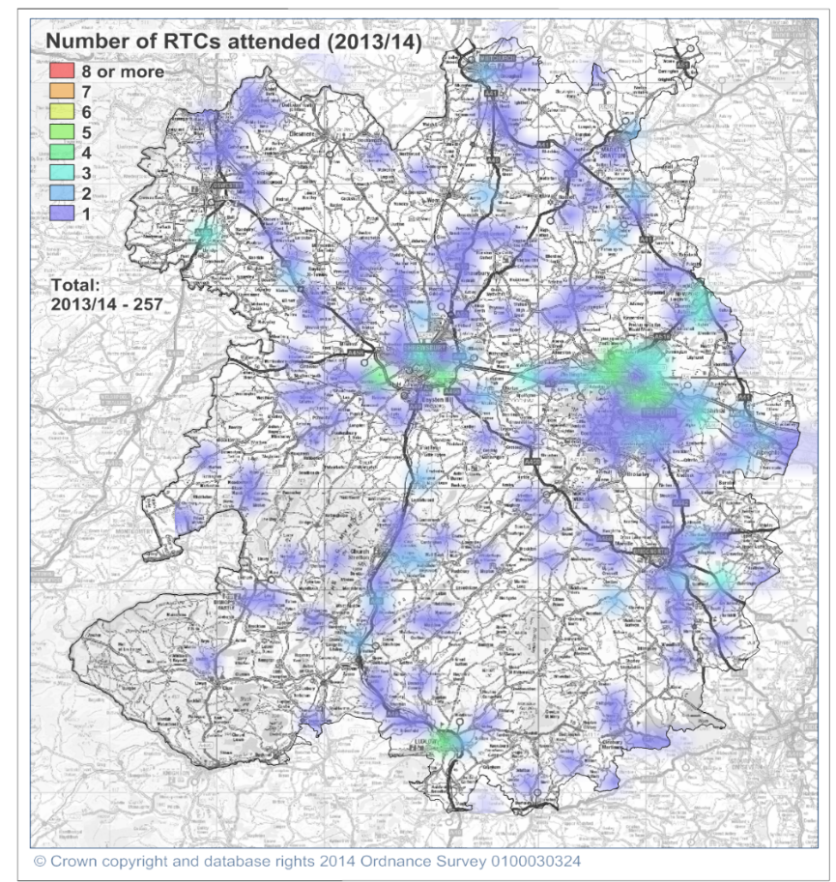
The graph above (Figure 7) shows the number of RTCs the Service has attended over the last five years and shows there has been a fairly steady reduction over that period. Map 6 below shows the density of RTCs attended by the Service during the last twelve months. The Safer Roads Partnership focuses its work on the areas with the highest density of incidents.
Map 6 – Location of RTCs attended by SFRS 2013/14

Protection

Safety at Work

The Service’s aim is to keep businesses in business, whilst ensuring they comply with the requirements of the Regulatory Reform (Fire Safety) Order (RRO) 2005.

SFRS works with local businesses to ensure that “Responsible Persons”, i.e. the persons in control of the premises, such as the landlord, owner or employer, possess the knowledge to keep their premises safe from fire. The Service carries out Fire Safety Audits (FSA’s) on all business premises in Shropshire, within the requirement of the RRO.

To do this effectively the Service operates a Risk Based Inspection Programme (RBIP), which uses the Community Fire Risk Management Information System (CFRMIS). CFRMIS identifies the properties, which are scheduled for an audit, based on their risk levels and the date the last audit was done. In 2013/2014 the Service carried out 1,603 audits on businesses in Shropshire and CFRMIS has identified a further 2,000 premises to be audited in 2014/2015.

The Service will also undertake post fire inspections to determine if poor management or other fire precautions could have played a role in the fire. This plays a part in our prevention and enforcement roles.

Fire Safety Audits are carried out by Fire Safety Inspecting Officers (FSIO’s) and Operational staff based at fire stations. This approach enables the Service to visit a large number of premises to check general compliance. An FSIO can carry out a more detailed audit on higher risk properties or those showing a lack of fire safety knowledge. SFRS employs the same policy, when carrying out visits to 7.2(d) properties and work in conjunction with fire station based staff to achieve this.

The Service also runs Business Education Seminars throughout the year. The seminars are designed to educate and inform businesses about their responsibilities. This preventative approach helps business owners and reduces the numbers of enforcement actions and prosecutions required.

These procedures have helped reduce the number of accidental business fires, which have shown a fairly steady decline over the last seven years (Figure 8).

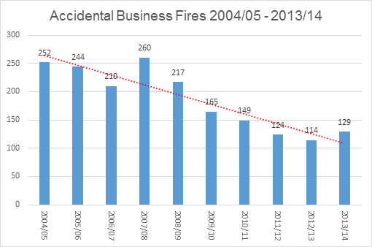

Figure 8 – Accidental Business Fires 2004/05 – 2013/14

Commercial Premises with Sleeping Accommodation

One of the particular risks the Service has identified during its work with Shropshire businesses is the threat posed by commercial premises, where sleeping accommodation is provided above or within the property. A comprehensive inspection programme has been undertaken in this type of premises and several prohibition notices have been served to overcome some very serious situations that have been identified.

The Service’s primary duty is to identify and audit these premises to ensure compliance with the RRO and reduce the threat to life they may pose. However, even when serving a legal notice of any kind, the Service is still conscious of the objective to keep businesses in business and support community sustainability.

Working with Partners

SFRS works closely with its partners and is always looking for new partnerships through engagement with Local Business Forums and the business community. We are also developing preliminary involvement in Primary Authority Partnerships through the Better Regulations Delivery Office (BRDO), to ensure compliance with legislation. The Service is also currently engaged in one Primary Authority Scheme with a major UK retailer.

The Service is constantly looking to add to the existing memoranda of understanding it has with Private Sector Housing Shropshire and Borough of Telford & Wrekin. We also review the application of the Local Authorities Co-ordinators of Regulatory Services (LACORS) agreement.

Building Regulations Consultation

SFRS undertakes building consultations and applies British Standards and Approved Documents to ensure new buildings meet fire safety requirements and within inclusive fire safety engineered solutions.

Consultation at the design stage of a new building gives the Service an opportunity to encourage the inclusion of safety features, like secure access and firefighting facilities for firefighters: in 2013/14, SFRS carried out 451 building regulation consultations.

Licensing Applications

Under the Licensing Act 2005 SFRS receives licensing applications and variations to licences for all premises that apply for a premises licence. As part of the consultation, the Service makes representations to the local Council Licensing Authority when appropriate.

Response

Through the ongoing process of IRMP, the Service identifies what operational capabilities we need to have and where they need to be to get the maximum advantage when responding quickly and effectively to all the identified risks. This is currently achieved by strategically siting 28 frontline fire engines and an array of specialist vehicles across the County at 23 fire and rescue stations. This network of stations is geographically located to support the Service in meeting its response standards.

The communities of Shropshire are spread sparsely across the County, so the current operational model is designed to allow each of our fire engines to be able to independently manage all risks for up to 20 minutes. During that time, reinforcements will be able to be dispatched and arrive on scene to support larger, more complex or developing incidents.

Through experience and statistical analysis, the current model crews the fire engines in 2 different ways. In the majority of the County, fire engines are crewed using Retained Duty System (RDS) staff. These are fully trained and qualified firefighters, who have other occupations, but provide on-call cover in the more rural areas with smaller towns and villages. This allows 23 of our fire engines to turn out within 5 minutes of receiving a call. It is a highly efficient way of providing a service in more rural areas, where call rates are lower.

In our larger towns of Shrewsbury and Telford, the fire engines are crewed by Whole-Time Duty System staff. This continuous crewing system involves “watches” of firefighters, working a rota system. This system provides an extremely reliable and resilient method of deploying 5 of the engines at an immediate turnout and was designed to be able to cope with high levels of activity. It also provides the capacity to undertake additional specialist training in areas, such as water rescue, and time for more prevention work in the more built-up areas.

Our performance against the Response Standards

In order to deliver the best emergency response to the people of Shropshire, the Service measures its performance against published response standards. This enables the Service to judge the effectiveness of its existing strategies and identify opportunities for improvement.

The outcomes of SFRS’s performance against the standards are published every year. Tables 5 and 6 below show the performance achieved against the Fire Authority’s Life Risk Fire Response Standards and the more strategic Public Value Response Standard for 2013/14.

 | Life Risk Fire Response Standard
Risk Areas | Time to get a minimum of 5 firefighters to an incident | Time to get a minimum of 8 firefighters to an incident
High | 10 minutes | 13 minutes
Medium | 15 minutes | 18 minutes
Low | 20 minutes | 20 minutes
Target | 85% | 85%
Actual Performance 2013/14 | 82% | 72%
Actual Performance 2012/13 | 82% | 68%

Table 5 – Performance achieved against the
Life Risk Fire Response Standards 2012/13 – 2013/14

 | Public Value Response Standard
For all emergency incidents | The first fire engine will arrive with a minimum of 4 firefighters within 15 minutes
Target | 87%
Actual Performance 2013/14 | 89%
Actual Performance 2012/13 | 89%

Table 6 - Performance achieved against the
Public Value Response Standard 2012/13 – 2013/14

Results for the last two years show that performance against the second element of the Life Risk Fire response standard has improved but remains below the target of 85%, as does the performance against the first element. The Service has recently improved its ability to measure against this standard and is looking to identify reasons for failure that can assist it in driving further improvements.

Performance against the more strategic Public Value measure has remained consistent over the last two years.

Our Operations Model is primarily designed to deal with the most commonly presented Incidents, such as property fires and road traffic collisions, but we need to be able to respond to, and manage, other less frequently encountered, but foreseeable risks.

Wild Land Fires

Wild land fires were recently added to the West Mercia Local Resilience Forum Community Risk Register and SFRS is developing plans to deal with this risk.

New off-road vehicles fitted with fire fogging units have improved SFRS’s ability to fight these fires and the development of links to other agencies has led to a more effective response. The effectiveness of these arrangements will be tested through joint exercises and real incidents.

English Heritage and SFRS have jointly run poster campaigns about the dangers of moorland fires at popular moorland sites. Fire Plans for specific risks are produced and updated annually. They provide information about available water supplies, access roads onto sites, landowners, land managers and gamekeepers etc.

Transport Risks

All frontline fire engines are equipped to deal with most road traffic collisions (RTCs) but very occasionally the problem is much bigger, especially when a ]large goods vehicle is involved. Consequently, the Service maintains a heavy rescue capability at Wellington Fire Station.

Rail incidents are uncommon but they are significant and present a specific set of risks and challenges. SFRS risk information, Standard Operating and Specific Incident Procedures and incident command assessments ensure that we are well prepared. The Command and Control Centre is connected to the Rail Operator to ensure that SFRS has up-to-date information on who and what is being carried on the rail network.

Aircraft incidents, though infrequent, are still a foreseeable risk and so SFRS prepares and trains for emergencies involving aircraft both on and off the airfield.

Most of Shropshire’s airfields are owned by the military. SFRS works closely with the Ministry of Defence to prepare for incidents on these sites and has developed Standard Operating and Specific Incident Procedures that are used with incident command assessments to ensure that any type of aircraft incident Is responded to appropriately.

Water Rescue
Open water like lakes, meres, pools, streams and rivers present a risk to life. In one year (2013/14), the Service attended 17 incidents involving either flooding or rescues from water incidents.

SFRS currently has eight strategically positioned Water First Responder Teams, a fully qualified Swift Water Rescue Team, and two boats based at Shrewsbury (Map 7 below). SFRS’s water rescue response capability aligns with guidance from the Department for Environment, Food and Rural Affairs (DEFRA), Flood Response National Enhancement Project. SFRS’s two boats are registered as Type B assets and are available to support national incidents.

Flood Response
The summer floods of 2007 and the winter floods of 2013/14 demonstrated Shropshire’s susceptibility to extreme flooding events. SFRS successfully responded to flooding locally, regionally and nationally. Experience drawn from these events, aided by working closely with partner agencies, helps SFRS to further develop its flood response skills.

The Local Resilience Forum has identified flooding as a major risk. The LRF partnership ensures a co-ordinated response to flooding in Shropshire and West Mercia.

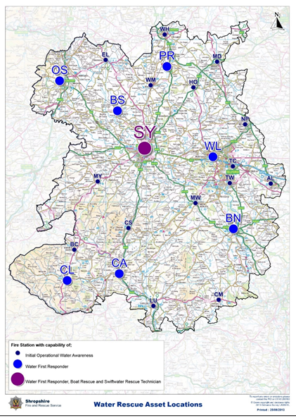

Map 7 – Location of SFRS Water Rescue assets

Collapsed Buildings
SFRS has the resources to manage small-scale building collapses and stabilise the scene at the initial stage of larger incidents, with specialist equipment and training for this type of incident based at Wellington Fire Station. For larger incidents, we are supported by Urban Search and Rescue (USAR) capabilities, available in Hereford and Worcester and West Midlands Fire and Rescue Services. The firefighters and search and rescue dogs of the USAR teams are available 24 hours a day and ready for deployment anywhere in the country.

Animal Rescue
Shropshire is a rural county and the need to rescue large animals is an ongoing issue. For example, in 2013/14 SFRS attended 39 animal rescue incidents. These continue to pose a significant risk of injury to the animals and to the rescuers alike. To manage the risk all operational personnel are trained on basic animal awareness but we have additional specialist training and equipment for this type of incident based at Wellington Fire Station. This capability was developed in collaboration with other services and Harper Adams University and is sustained through charitable donations.

Health, Safety and Welfare for the Operational Environment

Providing information, undertaking training and pre-planning are how we keep our firefighters safe and effectively resolve incidents.

Site Specific Risks and Operational Risk Information

SFRS continuously identifies new risk information and updates existing information in order to support the operational effectiveness of personnel, ensure the safety of the public and the protection of its firefighters.

SFRS monitors site-specific risks, shares information with partner agencies and liaises directly with larger risk sites. SFRS has a database that captures industrial, heritage and societal risks, which emerge from inspections carried out by firefighters. They inspect, identify and record the risks for specific properties to which they may be called. The Risk Information Database is invaluable in ensuring information is available for the swift resolution of emergency incidents and the safety of firefighters and this information is available on every one of our frontline fire engines via an on-board computer.

In some instances no risk information is available for a property, either because it does not warrant that level of planning, or because the planning is not complete, e.g. a new property. In such cases, firefighters have a range of Standard Operating and Specific Incident Procedures and, of course, their training and experience to help guide them to the safe resolution of any emergency incident. These Procedures are produced in line with national and regional documents and in conjunction with subject matter specialists, where necessary.

Training for Operational Effectiveness and Safety

The Service designs its training to reflect the type of emergencies that it may be called to deal with. Training is as realistic as possible, reflecting time constraints, confined spaces, differing times of the day or night, heat and smoke, working at height or on water and includes, as far as is reasonable, every type of incident the Service could expect to attend.

In June 2013, the Government published The Health, Safety and Welfare Framework for the Operational Environment to provide strategic-level guidance for planning health, safety and welfare in an operational environment. SFRS uses information from this framework to plan and implement training and operational activities.

Joint Emergency Services Interoperability Programme

SFRS has worked with its partners through the Joint Emergency Services Interoperability Programme (JESIP) to improve the ways in which the Service, along with its other emergency service partners, responds to major and complex incidents, feeding into regional and national policy.

Improving efficiency

Effective SFRS prevention and protection strategies to reduce risk and the appropriate distribution of new equipment have already enabled the Service to reduce its resources, yet deliver the same level of service to the communities of Shropshire.

Since 2012, the number of wholetime firefighters employed by SFRS has fallen from 200 to 181 and officer numbers have reduced from 29 to 22.

Following a risk analysis and a review of equipment requirements, SFRS has devised and implemented an alternative way of crewing the rescue tender. This has allowed the Service to continue to provide a high level of response to RTCs and other rescues, while enabling a further reduction in the number of whole-time personnel based at Wellington.

What more do we plan to do?
Proposed New Response Standards from 2015
As part of the Risk Analysis stage of the IRMP Process, members of the public and local councillors were invited to register their concerns about the terminology used in the Life Risk Response Standards. It emerged that the term ‘Low Risk Area’ was seen as a poor description, because it did not make clear that in an emergency the risk to individuals could not be categorised as high, medium and low.

As the risk levels were based on population statistics that have changed since the original standards were adopted in 2005 (see “Identifying Existing Risks”) and detailed results are now available from the 2011 national census, the Fire Authority suggests the following changes to the terminology used in the Life Risk Response Standards, as shown below (Table 7).

Previous Terminology | New Terminology | Definition
High Risk | Urban | Large Towns: Areas that have more than 10,000 population
Medium Risk | Town & Fringe | Small Towns and Large Villages: Areas with less than 10,000 population but more than approximately 1,000
Low Risk | Rural | Small Villages and Rural: Areas with a pre-defined level of population density with less than 1,000 population

Table 7 – Proposed new terminology for Life Risk Response Standards

Map 8 below shows the proposed IRMP Life Risk areas in Shropshire from 2015. The total property count, including all residential and commercial properties for each classification, is also shown.

The proposed change impacts on just two areas of the County. Firstly, growth in parts of Telford, especially in areas like Lawley, means that more of Telford is classified as ‘Urban’ and therefore attracts a 10-minute response target.

Similarly, due to population growth in Baschurch, Ruyton-XI-Towns, Prees and Prees Heath, the classification for these areas have changed from ‘Rural’, which has a 20-minute response standard, to ‘Town and Fringe’, that now has a 15-minute target time.

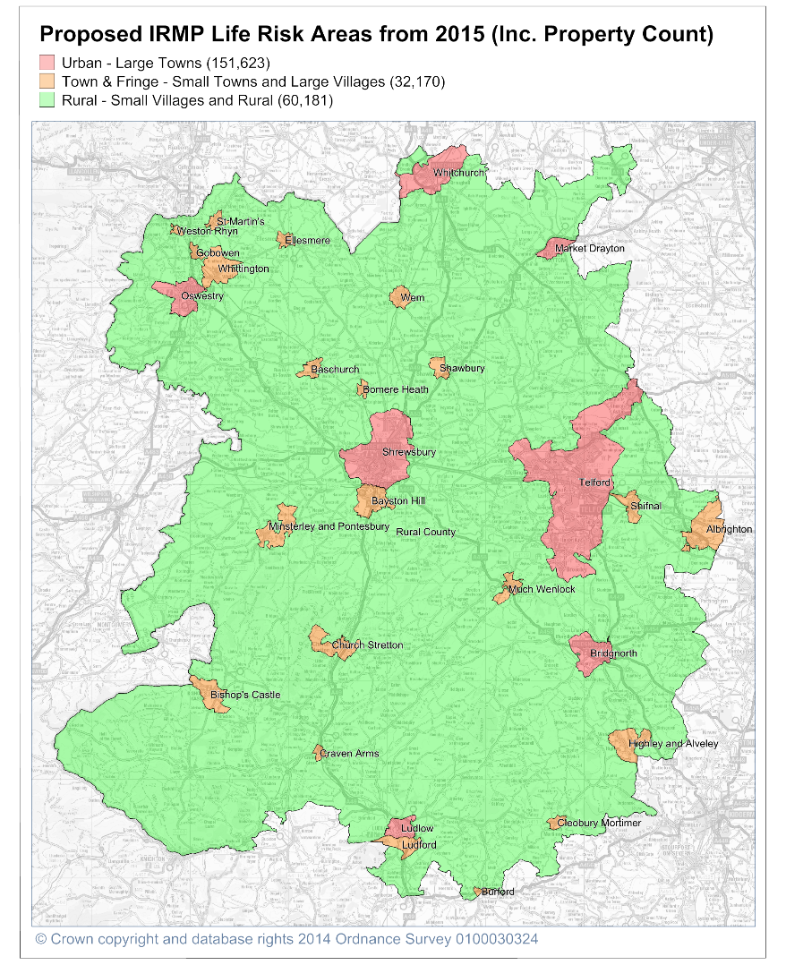

Map 8 – Proposed IRMP Life Risk Areas from 2015

Improvements to Prevention

Safety in the Home
SFRS will aim to reduce the incidence of accidental dwelling fires by 5% each year for the next five years.

The ‘Safety in the Home’ team will use partnerships with other agencies to ensure the vast majority of our activities are targeted to those most at risk. This includes the elderly, those living alone and others that are subject to the highest levels of deprivation. Our focus will be working with other agencies, e.g. by using other data sets to identify these individuals most at risk. We will then work in conjunction with partners to provide the most effective access to our most “hard to reach” groups and reduce the risks they face from fire and other emergencies.
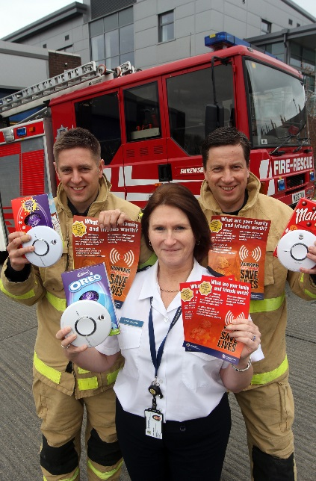
If we fit a smoke detector that is later found to be faulty, SFRS will replace it.

The Service will continue to stage eight campaigns each year, aimed at raising awareness of some of the most common causes of fire. We will increasingly use social media to increase their effectiveness and work with other partners to access the most vulnerable. The campaigns will be aligned with the seasonal threats of fire and include Child Safety Week, Summer Safety, the Electric Blanket Campaign and Chimney Safety. We also liaise with a range of local organisations to bring talks about fire safety awareness to the elderly and other vulnerable groups.

Deliberate Fire Setting Reduction

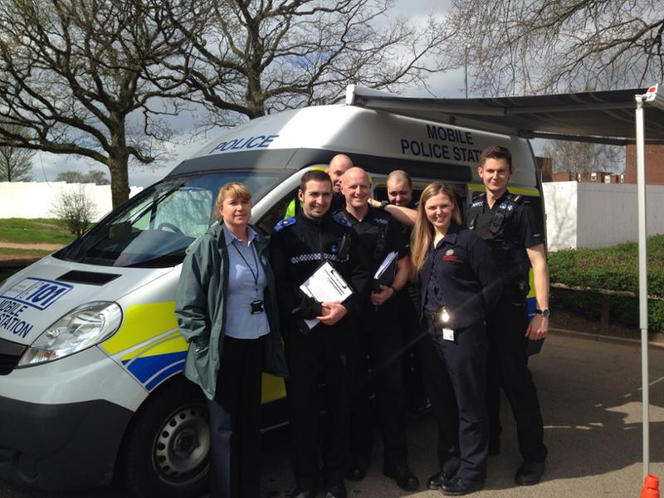
SFRS aims to reduce arsons by 5% each year for the next five years set against the performance figures of 2014/15.

The Safety in the Community Team will carry out arson prevention campaigns and home fire safety visits / advice. It will ‘target harden’, i.e. work with the Police to protect persons threatened with attack by fire from other persons. The Team can provide simple protective measures that will reduce the risk from that threat. The team work with a number of agencies and programmes and are involved in areas / organisations, such as the Sanctuary Project, threatened persons / dangerous persons, Multi-Agency Public Protection Arrangements (MAPPA), event planning (marches, rallies etc.), witness protection and hate crime targets.

SFRS will work with the Youth Offending Service to deliver an education plan for young people, fire safety education for Key Stage 3 (KS3) schoolchildren and a youth quiz, aimed at raising fire safety awareness in high-risk areas of social deprivation (13 schools have been identified).

In arson cases, effective fire investigation management will include patrols, direct community intervention work and analysis of the Incident Reporting System (IRS) Fire Crime data by Police and SFRS to ensure accuracy. Service personnel accompany Police Community Support Officers on patrols in our most vulnerable areas of the County to provide advice and guidance to local communities particularly threatened by arson and fire related anti-social behaviour.

Road Safety

SFRS will continue to work with partner agencies, such as Shropshire and Telford & Wrekin Council Road Safety Liaison, West Mercia Safer Roads Partnership and the Institute of Advanced Motorists (IAM) Young Drivers Scheme, to support the West Mercia Road Safety Strategy.

SFRS’s support for the Safer Roads Partnership is vital in ensuring the co-ordination of road safety publicity and marketing strategies, providing data, research and intelligence services to support road safety activities and in supporting West Mercia Police’s road safety strategy. The Safety in the Community Department aims to tackle the high motorcycle collision rate by attending the annual “Bikefest” events. SFRS will support Christmas “Drink Drive” campaigns and promote and feature other campaigns on the SFRS website and social media.

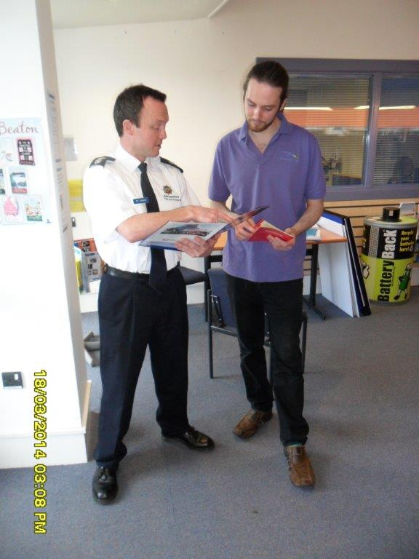
Fire Safety at Work

SFRS will continue to develop new and existing partnership arrangements to further enhance effectiveness and increase capacity to manage risks within the workplace.

SFRS aims to reduce accidental fires in businesses by 5% per year for the next five years set against the performance outcomes of 2014/15

Operational Response

SFRS will utilise the FSEC modelling tool and other statistical analysis to maintain and update this IRMP on an annual basis.

This information will be used to review and monitor operational resources to ensure SFRS has the right equipment and appliances to meet current and future risks in Shropshire. These are the Service’s response priorities:

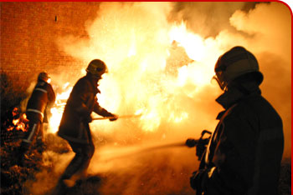
- Information for safe and effective incident ]management
- Positive pressure ventilation (PPV) of fires
- New and emerging risks
- Review of the Service’s Training Strategy
- Operational collaboration at regional level
- The 2020 Programme and beyond

Information for Safe and Effective Incident Management

SFRS will review its current local procedures against new national guidance and procedures and adopt two new nationally recognised programmes ‘The Provision of Operational Risk Information System’ and ‘Collaborative Partnership – National Operational Guidance Programme (NOGP)’.

The Provision of Operational Risk Information System (PORIS) seeks to provide a common approach to operational planning and risk management. It has been developed to assist fire and rescue services to:

- Meet their legislative responsibilities
- Maintain and, where necessary, improve their effectiveness and efficiency in managing the risks to their personnel
- Maintain interoperability with neighbouring fire and rescue services and other Category 1 and Category 2 responders. More information regarding Category 1 and 2 responders is set out in the Glossary.
- Manage and mitigate other risks in the communities that they serve.

SFRS will also develop a single corporate gazetteer, which will support PORIS to ensure that all the risk information relating to any premises can be held together and made available to firefighters, when dealing with incidents. Information for Incident Commanders will be enhanced through increased investment in mobile working.

The NOGP, which now includes the Collaborative Partnership (CP), is a collaboration between fire and rescue services and the Government to develop national operational doctrine and common operational ways of working. This will improve interoperability and remove some of the barriers that can impede the provision of fire cover across borders. SFRS has been a partner within the CP and will work collaboratively to develop and implement operational doctrine and procedures.

Positive Pressure Ventilation (PPV) of Fires

Following the successful introduction of post fire ventilation techniques the Service aims to increase the number of available fans and trained personnel at selected stations to ensure that every two-pump property fire will have a fan available. Post fire PPV reduces damage to property by rapidly expelling smoke and dangerous gases from buildings after a fire has been extinguished.

The Service will also review the potential for using PPV offensively. Offensive PPV has the potential to improve markedly conditions within buildings that are on fire in a way that improves survivability and firefighter safety but requires additional training and resources.

New and Emerging Risks

SFRS will consider how best to provide specialist response teams to deal with the threats posed by new and emerging risks, such as climate change, co-responding or provision of trauma care and the terrorist threat.

Review of the Services Training Strategy

SFRS will review its training strategy and policy in line with the risks identified in this IRMP. The overall objective is to ensure we are able to provide crews of fully competent firefighters on 100% of the occasions when the public call for our help.

What Resources Do We Need?

Operational Collaboration at Regional and National Level

SFRS already has a strong history of collaboration in both support services and the front line. It is intended that over the life of this IRMP, collaboration is strengthened both within the West Mercia operational footprint and more broadly across the West Midlands region and in support of National Resilience.

This will take the form of working through the Chief Fire Officers Association (CFOA) structure and an operational collaboration with partners within the West Mercia Local Resilience Forum. The objective is to increase SFRS capacity to develop and harmonise practices with neighbouring agencies, where this provides operational benefits. This will initially focus on operational and training policy and strategy but will progress to joint ventures in operational appliance and equipment procurement and training delivery.

The 2020 Programme and beyond

The 2020 Programme has been a process of engagement with the staff of SFRS, the public of Shropshire and other key stakeholders in the community to deliver change. The Programme has provided a method by which the process of improvement and change, necessary to ensure that SFRS is meeting the needs of the community in future, has been delivered. The methods within the Programme, such as engagement and consultation, will continue to be applied and will address the next tranche of work up to 2020 and beyond. The work includes reviews of work patterns, business processes and adoption of any other innovations that can yield a benefit to the people of Shropshire. The aim is to seek improvements in both the frontline and support elements of the Service. Significant changes will be fed into the IRMP or other parts of the Medium Term Corporate Plan, as the annual reviews and refreshes take place.

The priorities outlined here will be widely communicated within the Service to ensure that all staff know of them and can take responsibility for their own contribution to the range and quality of the service they provide. These are based on current and future risks and resource requirements. The detailed actions to meet the priorities are contained within the IRMP Action Plan (see Appendix A).

Integrated Crewing Model

As part of the IRMP process, the Service has undertaken a comprehensive risk review and, in consultation with the public, arrived at an operational model that requires 23 fire engines to be available within 5 minutes of a call being received and a further 5 fire engines on immediate turnout. To achieve this we currently use the Retained Duty System for the 23 and the whole-time duty system for the 5. Within this, we also crew a number of specialist vehicles, as described later in this section, but fundamentally, there are two crewing systems that operate independently.

Retained Duty System (RDS)

23 sections / stations each with a budget for either 18 or 14 units (each unit is based on one firefighter being available to provide immediate cover to staff a fire engine). The firefighter’s contract can be for up to 120 hours of cover per week but individuals can opt for a contract that covers 100% or 75% of this commitment. This requires an establishment of 342 units to provide at any one time 115 firefighters to crew 23 fire engines. The budget for this operation in 2014/15 was £2,827,042.

Whole-time Duty System (WDS)

This provides the resources for two fire engines in Shrewsbury, two in Telford and one at Wellington. At any given time, there will be 23 firefighters on duty (24 on nights). The WDS relies on four watches working a 2 days on, 2 nights on, 4 days off working pattern (2/2/4). The number of firefighters required across the stations for each watch is 34. This gives an establishment of 136 wholetime firefighters. The budget for this operation in 2014/15 was £5,180,508.

The RDS provides excellent value for money and is an efficient and effective resource model, providing activity levels, and subsequent demand on individual firefighters, are not too high.

The traditional WDS of 2/2/4 is an easily managed resource model that provides high levels of resilience and has been a very successful way of crewing, when the operational activity levels are very high. However, it is evident from the current operational activity levels in Shropshire that this resource model needs to be reviewed to identify other ways of working that are not so heavily resourced but still provide the same level of operational resilience.

The intention is to carry out a review to identify more efficient ways to provide the current operational model at a lower cost but with an improved performance. This will be achieved by focusing on how we can deliver an optimum crewing level at all times through an integrated crewing model.

Command and Control Centre (Fire Control)

SFRS Fire Control function currently operates on a 2/2/4 watch based model, which is augmented when necessary by RDS Fire Control staff. The RDS staff provide staffing resilience, which is an issue for Fire Control due to the relatively low numbers on each watch and the fact that Fire Control is a standalone function within the Service. Following staff and public consultation, the Fire Authority has decided that SFRS should retain its Fire Control function, rather than finding an external provider, but should find a more economical way to do it. It is therefore intended to carry out a review of Fire Control that will find new ways of working to improve the function in terms of both resilience and integration with the Operations Department.

SFRS Appliance Resources and Specialist Teams.

To achieve the current operational model SFRS needs to have a broad range of appliances, equipment and personnel with specialist skills that can be deployed individually or as part of a team.

The following section provides an overview of some of the Service’s resources. Further information on individual stations can be found in the SFRS Station Profile document available at www.shropshirefire.gov.uk

Fire Control

SFRS Fire Control is based in the Headquarters building in Shrewsbury. It consists of 4 operating terminals, featuring the SEED Command and Control mobilising system and an integrated telephony system. These systems enable Fire Control operators to receive all emergency calls, mobilise all of SFRS resources and contact other agencies involved in the incidents.

SFRS and Hereford and Worcester Fire and Rescue Service operate a mutual fall-back arrangement which allows each Service to assist the other during exceptionally busy periods or during a major incident. Fire Control personnel also perform a range of non-emergency administrative tasks for the Service.

28 x Frontline Fire Appliances
Standard response vehicle that can transport up to 9 operational personnel to emergency incidents. Standard firefighting equipment includes a minimum of 1,800 litres of water, hoses, ladders and rescue equipment to deal with road traffic collisions and other entrapment incidents.

10 x Incident Support Units (ISUs)
Toyota Hilux vehicles with off-road four-wheel-drive capability. These vehicles can carry a variable load and are used to support incidents involving fire, road traffic collisions, environmental protection and chemicals.

3 x Prime Movers (PMs)
Large vehicle capable of carrying different loads, using a special ‘pod’ system. This allows a single appliance to perform different roles. The foam pod or environmental protection unit outlined below are carried on a prime mover.

2 x Aerial Ladder Platforms (ALPs)
Specialist high-reach platforms, providing ladder access above the 32 metres that ladders carried on front line fire appliances can reach. This appliance can also deliver water from height and can be used as an observation platform or a working platform from which personnel can work safely at height for long extended periods.

2 x Incident Command Units (ICUs)
Mercedes Vito vans modified to become mobile control units, enabling the Service to deal with large and/or complex incidents. They carry additional communications equipment and planning facilities used for command support.

1 x Rescue Tender (RT)
Specialist vehicle, carrying a broad range of ‘heavy rescue’ equipment that allows it to support incidents, such as large goods vehicle accidents, building collapse or large animal rescue. The vehicle is also fitted with a Hi-ab crane and winch.

1 x Water Rescue Unit (WRU) consisting of 2 boats
Specialist vehicle, containing equipment to support personnel, who operate the Service’s boats for water rescue. Allows four personnel to be carried and will tow one of the two boats.

1 x Water Carrier (WC)
A large tanker vehicle, allowing the bulk carrying and delivery of water to an incident, where water from other sources, such as hydrants, is not sufficient or available.

1 x Landrover Pump (L4P)
Land Rover Defender with four-wheel-drive, off-road capability that allows it to deliver water to locations that frontline firefighting appliances cannot reach.

1 x Pinzgauer (L6P)
Specialist six-wheel-drive, off-road vehicle that can deliver water and limited equipment to very remote and difficult to access areas.

1 x Light Pumping Unit (LPU)
Specialist unit designed to pump water to an incident from open water, such as rivers and lakes. It is carried on a dedicated prime mover and has its own specialist personnel.

1 x Foam Pod (FP)
Carries foam concentrate and associated equipment designed to fight fires, where water is not suitable. This pod requires a prime mover to deliver it to the incident.

1 x Environmental Protection Unit (EPU)
This unit carries a variety of equipment to protect the environment and carry out salvage operations. It can be used to make dams, cover drains and mop up oil spills. Most of the equipment on this pod is provided by the Environment Agency and it requires a prime mover to deliver it to incidents.

1 x Heavy Pumping Unit (HPU) and Hose Layer
A specialist pump designed to deliver water from a water source, such as a river or lake, to a destination that may be several kilometres away. It can also be used to remove floodwater and supply water for firefighting. It requires a specialist crew and a prime mover.

1 x Welfare Unit (WU)
A purpose built toilet unit on a trailer

SFRS National Resilience Assets

The Government has provided SFRS with the appliances described below. These are operated by specialist personnel from Shropshire for use locally, regionally or nationally as part of the National Resilience project.

1 x High Volume Pumping Unit (HVPU) and Hose Layer
A specialist pump with capabilities and characteristics similar to those of the HPU unit, described above. This unit has been used to support regional and national operations such as the 2014 flooding in the south of the UK.

1 x Incident Response Unit (IRU)
Specialist appliance designed to support operations at a local, regional or national level. Its prime function is to enable the mass decontamination of the public following a terrorist attack or industrial accident.

1 x Re-robe Unit (RRU)
Specialist appliance designed to support members of the public and SFRS personnel at incidents, where people may have been contaminated. It carries large amounts of clothing for members of the public, who may have been affected, as well as decontamination facilities.

SFRS Specialist Teams and Roles
Firefighter Assistance and Safety Teams (FAST)
Wholetime firefighters, who support the safety of personnel at large, complex or extended incidents. They allow the Service to carry out and record risk assessments to help make incidents as safe as reasonably practicable. Normally only mobilised when four or more front line firefighting appliances are needed.

Water First Responders (WFRs)
Firefighters, trained for wading rescues, self-rescue and defensive swimming techniques.

Swift-water Rescue Technicians (SRTs)
Firefighters, trained for dynamic water rescues and the searching of rivers and open water. They are trained to swim to rescue casualties as well as wading rescues.

DEFRA declared Type B Water Rescue Team
6 SRT trained personnel and a motorised boat capable of travelling against water flowing up to 10 mph. The Team also has a welfare officer or team manager. This team has been registered with the Department for Environment, Food and Rural Affairs (DEFRA) and can be used to support incidents anywhere.

Water Incident Managers (WIMs)
Officers, who have completed a course on water incident management and are skilled in incident appraisal, management and resource allocation.

Subject Matter Advisors (SMAs)
For flooding incidents, high volume pumping and flood rescue. Tactical advisors for use at operational, tactical and strategic level, who can provide detailed information about teams and personnel capabilities and types of equipment suitable for use at incidents. They can also be used to help plan and run communications and operations at wide scale flooding events and other large incidents.

Animal Rescue Teams (AR2s/AR3s)
Firefighters, trained in specialist techniques and procedures for use at incidents involving large animals.

Line Safety Teams
Firefighters trained to use lines and equipment for work restraint, work positioning or fall arrest techniques for rescuing or working at an incident.

Hazardous Materials and Environmental Protection Officers (HMEPOs)
Officers trained to advise on the tactical decisions and protective clothing required to deal with incidents involving chemicals. They liaise with the Environment Agency for environmental protection, advice and instruction.

Scientific Advisors
On call resource used by the HMEPOs and others to give specialist advice on incidents involving chemicals.

National Inter–Agency Liaison Officers (NILOs)
A tactical, security-cleared advisor trained to deal with any multi agency incident. They can also provide detailed information on fire service capabilities and requirements at an incident and can be used in pre-planning events.

Fire Investigation Officers (FIOs)
Officers, equipped with additional knowledge and training to investigate the cause of a fire.

Fire Crime Officer (FCO)
An officer who works with partner agencies on arson reduction strategies and techniques.

As part of the IRMP process the requirement for these capabilities and teams is kept under review.

This Plan has set out what the Service intends to do over the period 2015 to 2020 to ensure that it continues to deliver services effectively and efficiently. The Plan looks at current and future risk and what the Service is doing to protect people, buildings and the natural environment from fire and other emergencies. It also looks at how the Service will deliver its fire and emergency response services by matching the risks it has identified to the resources it deploys, for the benefit of the local community.
Consultation

Consultation and Engagement

The Fire Authority will continue to comply with the “Code of Practice on Written Consultation”, issued by the Cabinet Office (November 2000) as well as the Office of the Deputy Prime Minister’s “IRMP Guidance Note 2 – Consultation” (July 2003).

These documents state: “the guiding principle in deciding how extensively you consult is that any person or organisation that might have a legitimate interest in the proposals under consideration, or who may be affected by those proposals, should have the opportunity to express their views”.

The Fire Authority has provided everyone the opportunity to comment on these proposals but continues to seek views as the proposals are put in place.

Public Consultation

SFRS is a community service paid for largely from local taxes e.g. council tax. The public can have its say and influence how the Service is managed and delivered. Meetings of the Fire Authority and its relevant committees are open to the public to attend and reports and minutes arising from these meetings are published on the Service website. Feedback is always welcome. Comments, complaints or compliments can be offered via our website, by phone or in person. You can also request Service information or data.

You can email IRMP.Team@shropshirefire.gov.uk or phone 01743 260200 for alternative ways to comment.

Strategic Partner and Stakeholders Consultations

A list of the organisations with whom the Service consulted in developing this IRMP is included in Appendix B. These organisations can also provide any further feedback using the methods described above.

Staff consultation

The Chief Fire Officer and his management team regularly engage with all members of staff during face-to-face briefing sessions carried out at various SFRS locations.

These sessions were held with small groups of staff, allowing them to receive accurate information on SFRS plans and an opportunity to question officers in a more relaxed environment. The current budgetary position, a review of the duty systems and an ongoing review of Fire Control options are just some of the things that have been discussed at these sessions.

The priorities outlined here will be widely communicated within the Service to ensure that all members, of staff know of them and can take responsibility for their own contribution to the range and quality of the service they provide. These are based on current and future risks and resource requirements. The detailed actions to meet the priorities are contained within the IRMP Action Plan (see Appendix A).

Appendix A – IRMP Action Plan 2015-20

IRMP Action Plan 2015-20

The approved changes to the IRMP Response Standards, including the changes to the terminology used and the target levels for specific parts of the county, will be implemented for 1 April 2015 and will be monitored through the life of this plan.

Action ID | Description | 2015/16 | 2016/17 | 2017/18 | 2018/19 | 2019/20
IRMP/1 | Undertake a project to identify all possible options that could reduce the current wholetime staffing costs by approximately £400k per annum, whilst continuing to deliver a service matched to risk. | Review | Implementation in accordance with approved outcomes
IRMP/2 | Undertake a Fire Control Review project, which should identify alternative options for improving the cost effectiveness of the Fire Control function by up to £300k per annum. | Review | Implementation in accordance with approved outcomes
IRMP/3 | Review of Telford Central site requirements, including fire station, training facilities and multi-agency opportunities | Review | Implementation in accordance with approved outcomes
IRMP/4 | Replacement of current operational systems, including:  - Implement National Operational Guidance processes  - MDT* hardware and software  - PORIS⁺ software and integration with a corporate Gazetteer  Include consideration of the potential introduction of incident ground mobile working. | Explore and select appropriate options | Implementation in accordance with approved outcomes
IRMP/5 | Incident Command Vehicle replacement, including consideration for the potential introduction of incident ground mobile working. | Identify appropriate options and implement
IRMP/6 | Introduction of the new national Emergency Services Network (ESN) | Ongoing national project |  | Implementation
IRMP/7 | Rescue Tender resilience review | Review | Implement
IRMP/8 | Aerial capability resilience review |  | Review | Implementation
IRMP/9 | Fire engine replacement programme, including new ways of working review. | Review |  | Implementation in accordance with approved outcomes
IRMP/10 | Review the Business Fire Safety Department and ensure it is delivering the right service, at the right cost, ensuring the right levels of safety are provided for staff and the communities we serve. | Implementation of approved outcomes
IRMP/11 | Review the provision of specialist team capabilities within the Service area, including areas such as:  - Climate Change  - Enhanced trauma care capabilities  - Marauding Terrorist Firearms Attacks (MTFA) |  |  | Review | Implementation in accordance with agreed outcomes
IRMP/12 | Review the Service’s training strategy and policies, in line with this IRMP action plan and identified risks. | Review |  | Implementation in accordance with Service and IRMP requirements
IRMP/13 | Review our internal structures to identify more efficient ways to provide frontline services, whilst aiming to maintain the highest levels of service delivery. | Continuous activity
IRMP/14 | Reduce the Capital Reserves contributions by £120k per annum | Implement
IRMP/15 | Reduce the Ill Health Retirements contributions by £80k per annum | Implement
IRMP/16 | Reduce the Recruitment Advertising budget by £7k per annum | Implement
IRMP/17 | Reduce the Medical Reports budget by £6k per annum | Implement
IRMP/18 | Continue with the commitment to reduce the Support Staff pay budget by £105k by 2020 | Implement
IRMP/19 | Review the current Hydrants Contract prior to the next contract renewal date (2017), with the aim of exploring all possible options for cost reduction. |  | Review | Implementation

The list below shows the stakeholder organisations that SFRS will consult with during the IRMP process.
Appendix B - Stakeholder Organisations

Shropshire Council
Telford & Wrekin Council
Shropshire Association of Local Councils
District Auditor
Shropshire Health Authority
Shropshire Community & Mental Health
The Shrewsbury and Telford Hospital NHS Trust
The Robert Jones & Agnes Hunt Orthopaedic Hospital NHS Foundation Trust
West Midlands Ambulance Service
West Mercia Constabulary
Staffordshire Fire and Rescue Service
Cheshire Fire and Rescue Service
Mid and West Wales Fire and Rescue Service
North Wales Fire and Rescue Service
Hereford and Worcester Fire and Rescue Service
West Midlands Fire and Rescue Service
Cleveland Fire Brigade
Communities and Local Government Department
Chief Fire and Rescue Advisor
National Trust
English Heritage
Environment Agency
Defence Fire Services
RAF Shawbury
RAF Cosford
Defence Storage and Distribution Centre Donnington
Her Majesty’s Prison Stoke Heath
Mountain Rescue, Shropshire Hills Rescue Team
Local Members of Parliament
Shropshire Information Service
Shropshire Chamber of Commerce
Economic Regeneration Departments, Shropshire Council and Telford & Wrekin Council
Trading Standards Departments, Shropshire Council and Telford & Wrekin Council
Shropshire Federation of Small Businesses
Shropshire Women’s Institute
British Approvals for Fire Equipment (BAFE)
British Red Cross - FESS

Appendix C - Glossary
Collaborative Working
Working jointly or co-operating with others.

Co-responding
Accompanying another in the delivery of services, or providing first response for another organisation (i.e.:- Fire Service personnel trained in basic life support to assist the Ambulance Service).

Establishment
This is the measure of the number of people employed by the Service. This includes posts that are filled and/or currently vacant.

Fire Appliance
This is a generic term for any responding fire service vehicle.

Fire and Rescue Authority Members
These are Elected Councillors from each of the two administrative districts in Shropshire who sit on the Fire Authority.

Mobilisations
Where a rescue pump/appliance has been sent to an incident (even if they are turned back before arrival).

Personal, Protective Equipment (PPE)
Equipment used by Firefighters to protect their safety during an incident, this could be breathing apparatus or clothing for example.

Primary Fires
Primary fires include all fires in buildings, vehicles and outdoor structures or any fire involving casualties, rescues or fires attended by five or more appliances.

Response Standards
A risk based target for response times and number of personnel the Fire Authority aims to deliver to all relevant emergency incidents in Shropshire.

Retained Duty System ‘On call’ Firefighters
Retained Duty System ‘On call’ Firefighters work on a ‘standby’ basis, for responding to emergency calls. They are paid both an annual retainer and fees for attending training, emergencies and giving fire safety advice. Retained Duty System Firefighters usually live or work within five minutes of their local fire station. This enables them to respond quickly to emergency calls.

Risk Analysis
This is the process of examining in detail the risks in our community.

Road Traffic Collision (RTC)
This is an accident involving vehicles on the roads.

Secondary Fires
A Secondary fire is a fire involving items or objects that do not have any financial value (e.g. rubbish or grass fires)

Shift Pattern
The working hours or rota that personnel and Watches work to.

Watch
One of four shift groups who provide cover 24/7 cover. This could be Firefighters or Control operators.

Wholetime
Permanent contract operational staff e.g. Firefighters.

Alternative Formats

We can provide information, on request, in other formats including large print, audio and in community languages other than English. Please be aware that it may take a short time to produce a copy to your exact requirements.

Please contact the Equality and Diversity Officer on 01743 260 236.

